Functional attributes
- completeness meets specifications
- correctness
- appropriateness meets expectations?
non-functional attributes
- usability
- reliability
- availability uptime
- portability can it be run on different computer systems
- testability
- scalability reaching the limit of upgrading infrastructure
- flexibility design (new stuff)
- reusability need other attributes to be high quality (otherwise reusing buggy code)
- maintainability changes that don’t chance core functionality of software (integrating to server)
- interoperability
- performance quickness
- security invisible, neglected

types of tests
- unit testing checking small pieces of codes
- integration testing that units work together
- system testing the overall (user focused)
- Acceptance testing checks the requirements are met (functional and non-functional)

what do we test?
option 1: list the requirements
  - shall = must be done and is feasible
  - should = might be a compromise, but beneficial to the system overall
option 2: write user stories w/ acceptance criteria
  - as a <user>, I want to <action>, so I can <achieve the goal>
  - given, when, then
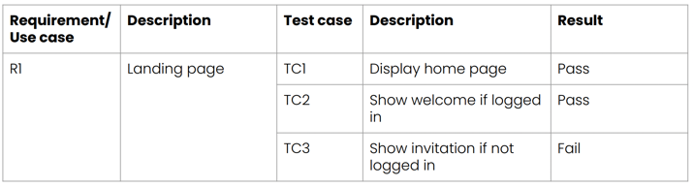
requirement traceability matrices
  - keeps track
  - use it to explain progress

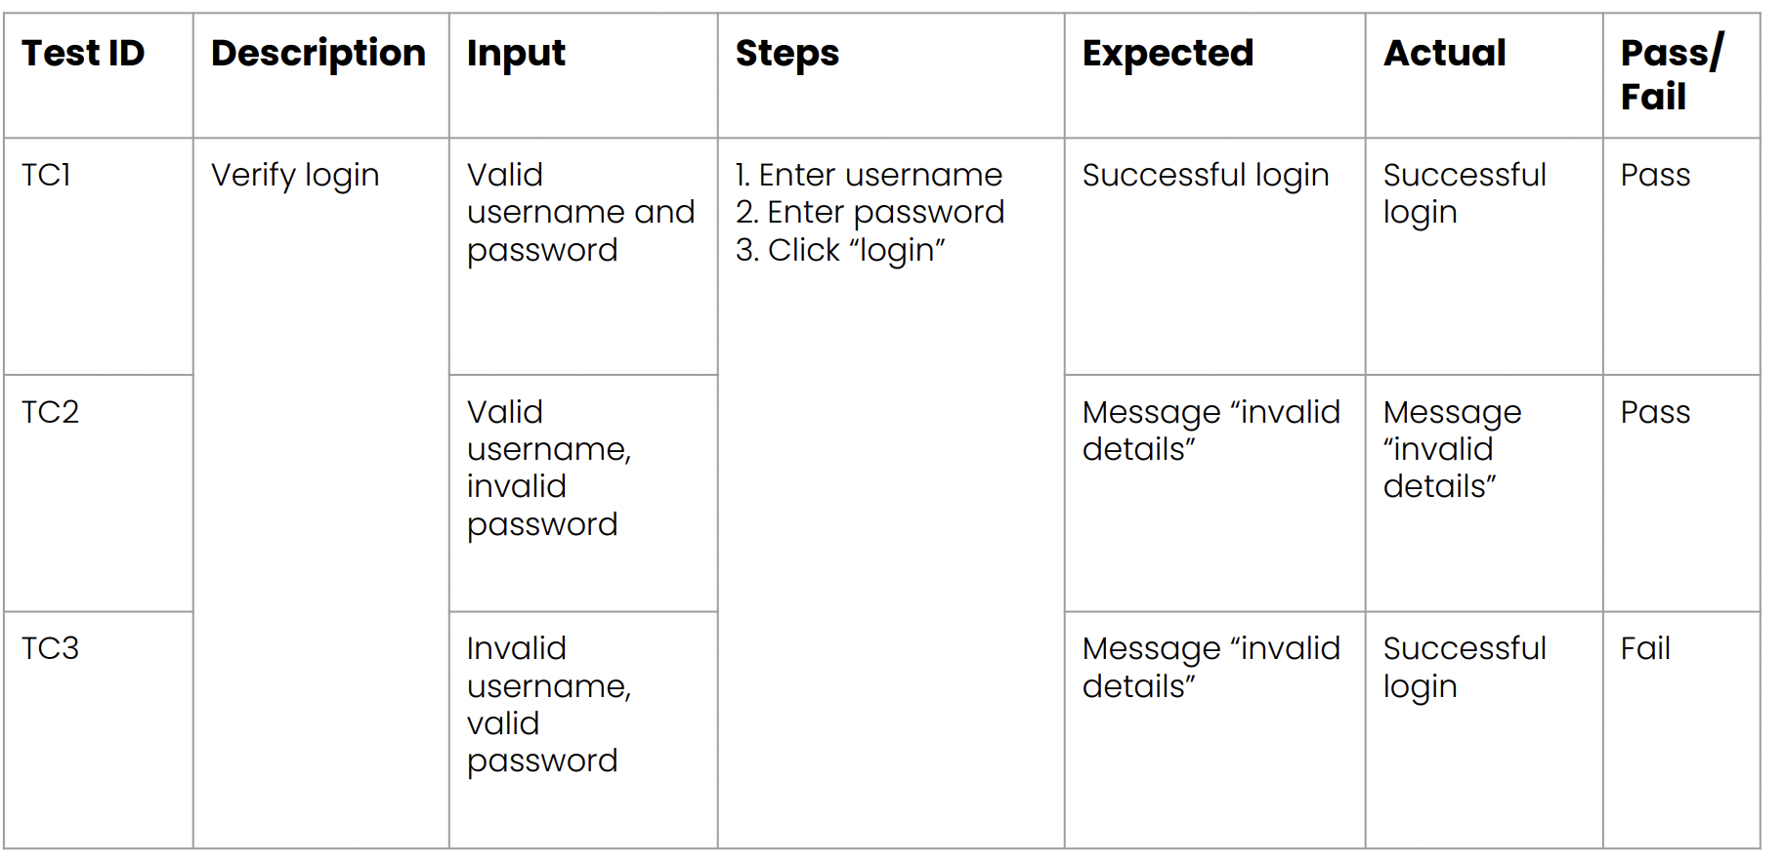

writing bug reports
  - assigned severity
